**VMWare Infrastructure Power Documenter**

**PowerDocument script syntax**

*New-VMWareInfrastructureReport parameters*

Parameter List

|  |  |  |
| --- | --- | --- |
| Parameter | Description | Mandatory |
| -outputType | Values:  *WordProcessingML* (for Word reports) *SpreadsheetML* (for Spreadsheet reports) | Yes |
| -ReportType | Report to be created  Possible values for *WordprocessingML* reports are:  *inventory* : DataCenter Inventory report  *vm* : virtual machines report  *vmstats*: virtual machines statistics report  *vmevents*: virtual machines events report  *serverevents*: server events report  *servertasks*: server tasks report  Possible values for *SpreadsheetML* reports are:  *vm* : virtual machines report  *vmstats*: virtual machines statistics report  *servertasks*: server tasks report | Yes |
| -path | Path (including file name) where the report will be saved | Yes |
| -serverIp | ESX Server ip address to generate the report from | Yes |
| -user | ESX Server user name | Yes |
| -password | ESX Server user password | Yes |
| -company | Your company name | No |
| -wordStyleTemplate | Path to the style document template for wordprocessingml documents (if not indicated “wordprocessingmlstyledocument.docx” default value is assigned) | No |
| -spreadsheetStyleTemplate | Path to the style document template for spreadsheetml documents (if not indicated “spreadsheetstyledocument.docx” default value is assigned) | No |
| -filterColumn | Column to filter report by (for spreadsheet reports) Values depend on report type | No |
| -filterValue | Value to filter the report by (for spreadsheet reports) Values depend on report type | Yes (if –filterColumn parameter is present) |
| -chart | If this parameter is present it indicates that a chart will be created using the report data (for spreadsheet reports) | No |
| -chartType | Possible values:  bar  pie | No |
| -chartXColumns | Indicates the columns to take the values from for the X axe in for the chart (see –chart parameter) | Yes (if –chart parameter is present) |
| -chartYColumn | Indicate the column to take the value for Y axe for the chart (see –chart parameter) | Yes (if –chart parameter is present) |

**Reports**

**DataCenter Inventory Report**

WordProcessingML format

Syntax:

*.\New-VMInfrastructureReport.ps1 -fileName [reportFileName] -outputType* ***"wordprocessingml"*** *-reportType* ***"inventory"*** *-wordStyleTemplate [wordstyletemplatepath] -company [companyname] -serverIp [esx server ip address] -user [esx user name] –password [esx user password]*

Sample:

.\New-VMInfrastructureReport.ps1 -fileName "datacenterInventoryReportSample.docx" -outputType "wordprocessingml" -reportType "inventory" -wordStyleTemplate "wordprocessingmlStyleTemplate.docx" -company "Your Company Name Here" -serverIp 10.0.1.70 -user root -password pass@word1

The output for previous command could be seen at “datacenterinventoryreportSample.docx” provided along with the Product Guide.

**Virtual Machines Report**

WordProcessingML format

Syntax:

*.\New-VMInfrastructureReport.ps1 -fileName [reportFileName] -outputType* ***"wordprocessingml"*** *-reportType* ***"vm"*** *-wordStyleTemplate [wordstyletemplatepath] -company [companyname] -serverIp [esx server ip address] -user [esx user name] –password [esx user password]*

Sample:

.\New-VMInfrastructureReport.ps1 -fileName "vmReportListSample.docx" -outputType "wordprocessingml" -reportType "vm" -wordStyleTemplate "wordprocessingmlStyleTemplate.docx" -company "Your Company Name Here" -serverIp 10.0.1.70 -user root -password pass@word1

The output for previous command could be seen at “vmlistreportSample.docx” provided along with the Product Guide.

SpreadSheetML format

Syntax:

*.\New-VMInfrastructureReport.ps1 -fileName [reportFileName] -outputType* ***"spreadsheetml"*** *-reportType* ***"vm"*** *-spreadsheetStyleTemplate [spreadsheetstyletemplatepath] -company [companyname] -serverIp [esx server ip address] -user [esx user name] –password [esx user password]*

Samples:

Normal report

.\New-VMInfrastructureReport.ps1 -fileName "vmListReportSample.xlsx" -outputType "spreadsheetml" -reportType "vm" -spreadsheetStyleTemplate "spreadsheetmlStyleTemplate.xlsx" -company "Your Company Name Here" -serverIp 10.0.1.70 -user root -password pass@word1

The output for previous command could be seen at “vmListReportSample.xlsx” provided along with the Product Guide.

Filtered report

.\New-VMInfrastructureReport.ps1 -fileName "vmListReportSampleFiltered.xlsx" -outputType "spreadsheetml" -reportType "vm" -spreadsheetStyleTemplate "spreadsheetmlStyleTemplate.xlsx" -company "Your Company Name Here" -serverIp 10.0.1.70 -user root -password pass@word1 **-filterColumn name -filterValue "staff_vmware01"**

The output for previous command could be seen at “vmListReportSampleFiltered.xlsx” provided along with the Product Guide.

**Virtual Machine Statistics Report**

WordProcessingML format

Syntax:

*.\New-VMInfrastructureReport.ps1 -fileName [reportFileName] -outputType* ***"wordprocessingml"*** *-reportType* ***"vmstats"*** *-wordStyleTemplate [wordstyletemplatepath] -company [companyname] -serverIp [esx server ip address] -user [esx user name] –password [esx user password] –filterColumn [column name to filter report by] –filterValue [value to filter the report by]*

Samples:

.\New-VMInfrastructureReport.ps1 -fileName "vmStatisticsReportSample.docx" -outputType "wordprocessingml" -reportType "vmstats" -wordStyleTemplate "wordprocessingmlStyleTemplate.docx" -company "Your Company Name Here" -serverIp 10.0.1.70 -user root -password pass@word1

The output for previous command could be seen at “vmstatisticsreportSample.docx” provided along with the Product Guide.

SpreadSheetML format

Syntax:

*.\New-VMInfrastructureReport.ps1 -fileName [reportFileName] -outputType* ***"spreadsheetml"*** *-reportType* ***"vmstats"*** *-spreadsheetStyleTemplate [spreadsheetstyletemplatepath] -company [companyname] -serverIp [esx server ip address] -user [esx user name] –password [esx user password] –filterColumn [column name to filter report by] –filterValue [value to filter the report by] –chart [optional parameter, if present it indicates that you want to create a chart from report information] –chartXColumns [columns for taking the chart X axe values] –chartYColumn [column for taking the Y axe values] –chartType [chart type]*

Samples:

Normal report

.\New-VMInfrastructureReport.ps1 -fileName "vmStatsReportSample.xlsx" -outputType "spreadsheetml" -reportType "vmstats" -spreadsheetStyleTemplate "spreadsheetmlStyleTemplate.xlsx" -company "Your Company Name Here" -serverIp 10.0.1.70 -user root -password pass@word1

The output for previous command could be seen at “vmstatisticsreportSample.xlsx” provided along with the Product Guide.

Filtered and Chart Report

.\New-VMInfrastructureReport.ps1 -fileName "vmStatsReportAndChartSample.xlsx" -outputType "spreadsheetml" -reportType "vmstats" -spreadsheetStyleTemplate "spreadsheetmlStyleTemplate.xlsx" -company "Your Company Name Here" -serverIp 10.0.1.70 -user root -password pass@word1 **-chart -chartType bar -chartXColumns value -chartYColumn timestamp -filterColumn MetricId -filterValue "cpu.usagemhz.average"**

The output for previous command could be seen at “vmStatsReportAndChartSample.xlsx” provided along with the Product Guide.

**Virtual Machine Events Report**

WordProcessingML format

Syntax:

*.\New-VMInfrastructureReport.ps1 -fileName [reportFileName] -outputType* ***"wordprocessingml"*** *-reportType* ***"vmevents"*** *-wordStyleTemplate [wordstyletemplatepath] -company [companyname] -serverIp [esx server ip address] -user [esx user name] –password [esx user password]*

Sample:

.\New-VMInfrastructureReport.ps1 -fileName " vmeventsreportSample.docx" -outputType "wordprocessingml" -reportType "vmevents" -wordStyleTemplate "wordprocessingmlStyleTemplate.docx" -company "Your Company Name Here" -serverIp 10.0.1.70 -user root -password pass@word1

The output for previous command could be seen at “vmeventsreportSample.docx” provided along with the Product Guide.

**Server Events Report**

WordProcessingML format

Syntax:

*.\New-VMInfrastructureReport.ps1 -fileName [reportFileName] -outputType* ***"wordprocessingml"*** *-reportType* ***"serverevents"*** *-wordStyleTemplate [wordstyletemplatepath] -company [companyname] -serverIp [esx server ip address] -user [esx user name] –password [esx user password]*

Sample:

.\New-VMInfrastructureReport.ps1 -fileName "serverEventsReportSample.docx" -outputType "wordprocessingml" -reportType "serverevents" -wordStyleTemplate "wordprocessingmlStyleTemplate.docx" -company "Your Company Name Here" -serverIp 10.0.1.70 -user root -password pass@word1

The output for previous command could be seen at “servereventsreportSample.docx” provided along with the Product Guide.

**Server Tasks Report**

WordProcessingML format

Syntax:

*.\New-VMInfrastructureReport.ps1 -fileName [reportFileName] -outputType* ***"wordprocessingml"*** *-reportType* ***"servertasks"*** *-wordStyleTemplate [wordstyletemplatepath] -company [companyname] -serverIp [esx server ip address] -user [esx user name] –password [esx user password]*

Sample:

.\New-VMInfrastructureReport.ps1 -fileName "serverTasksReportSample.docx" -outputType "wordprocessingml" -reportType "servertasks" -wordStyleTemplate "wordprocessingmlStyleTemplate.docx" -company "YourCompany Name Here" -serverIp 10.0.1.70 -user root -password pass@word1

The output for previous command could be seen at “servetasksreportSample.docx” provided along with the Product Guide.

SpreadsheetML format

Syntax:

*.\New-VMInfrastructureReport.ps1 -fileName [reportFileName] -outputType* ***"spreadsheetML"*** *-reportType* ***"servertasks"*** *-spreadsheetStyleTemplate [spreadsheetstyletemplatepath] -company [companyname] -serverIp [esx server ip address] -user [esx user name] –password [esx user password] –filterColumn [column name to filter report by] –filterValue [value to filter the report by] –chart [optional parameter, if present it indicates that you want to create a chart from report information] –chartXColumns [columns for taking the chart X axe values] –chartYColumn [column for taking the Y axe values] –chartType [chart type]*

Sample:

.\New-VMInfrastructureReport.ps1 -fileName "serverTasksReportSample.xlsx" -outputType "spreadsheetml" -reportType "serverTasks" -spreadsheetStyleTemplate "spreadsheetmlStyleTemplate.xlsx" -company "Your Company Name Here" -serverIp 10.0.1.70 -user root -password pass@word1

The output for previous command could be seen at “servetasksreportSample.xlsx” provided along with the Product Guide.

**Styling WordProcessingML Power Documenter Reports**

Styling in WordProcessingML Power Documenter Reports is managed through the “Power Tools for Open Xml” Get-OpenXmlStyle and Set-OpenXmlStyle cmdlets. This means that I use a WordProcessingML document as a styles template in order to define custom styles and then I set those styles to the report paragraphs when creating the report open xml markup at Power Documenter Script (see ##Setting Paragraph style comments at script source code) . If a Power Documenter user wants to change the look & feel for a WordProcessingML Power Documenter report, he or she can create a copy of the styles template document provided along with the script (I don’t recommend to modify this file directly) change the styles settings (don’t change the styles name) and pass this new styles template to the Power Documenter script.

Style template document for WordProcessingML provided along with the Power Documenter script is called “wordprocessingmlStyleTemplate.docx”

Note: If you want to your use your own styles you have to create those styles at the style template document and change the style name at proper Open Xml paragraph markup at Power Shell script

**Styling SpreadSheetML Power Documenter Reports**

Styling in SpreadsheetML Power Documenter Reports is very similar to styling for WordProcessingML Power Documenter Reports. The main difference is that setting the style for a cell is managed through the Set-OpenXmlSpreadSheetCellStyle cmdlet provided by Power Tools for Open Xml instead of doing so directly at the markup.

Same considerations for creating own style template documents for WordProcessingML reports apply to SpreadsheetML reports.

Style template document for SpreadSheetML provided along with the Power Documenter script is called “spreadsheetmlStyleTemplate.docx”

Note: If you want to your use your own styles you have to create those styles at the style template document and change the style name at proper Open Xml paragraph markup at Power Shell script.

**Filtering reports**

SpreadsheetML reports allow the user to filter the report by a specific value in a specific column. In order to specify the column and value to filter the report by you must use the –FilterColumn and –FilterValue parameters respectively.

Valid values for –FilterColumn and –FilterValue depend on the report type. We recommend to generate a Normal (not filtered) report in order to realize about possible values for –FilterColumn (those are the table headers at report) and possible values for –FilterValue (those are the colum values for the respective table header you want to use as -FilterColumn).

The following picture illustrates this situation with a “Normal” Virtual machine statists report:

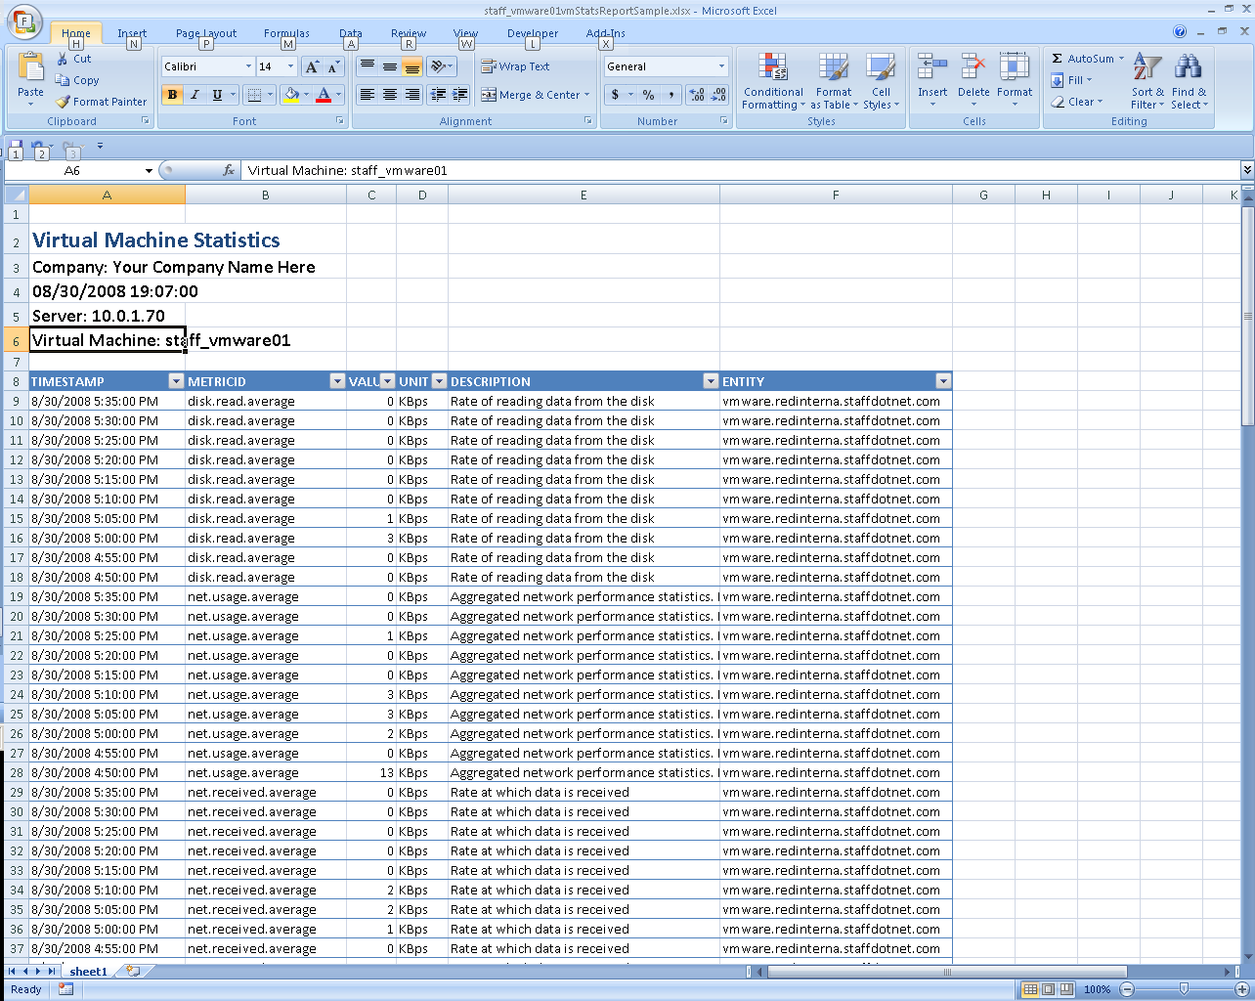

These are the possible values for –FilterValue if you use METRICID as the –FilterColumn (you can use only one at a time)

These are the possible values for –FilterColumn for a Virtual Machine statistics report

**Charting reports**

SpreadsheetML reports allow the user to create charts from the report information (this is particularly useful when combining with Filtering). If you want to create a chart you have to specify the –chart parameter at command line and use the –chartType, -chartXColumns and –chartYColumn for setting the chart underlying data. Possible values for –chartXColumns and –chartYColumn can be determined the same way as determining the possible values for –FilterColumn parameter (see Filtering reports section)